1. <https://www.youtube.com/watch?v=8OhINokx5As&list=PL3cFiqLUjlYPGlWWszesTtdI3v0tcLe5E&index=4>
2. **Agenda**:
   1. Diagram

      Description automatically generated
3. Chart, funnel chart

   Description automatically generated  
   In last lecture, we noticed that while formatting Sensex or Nifty (basically both are index), we have to include some companies in the index (Nifty Index, Sensex Index).
   1. Now the question is what is the base of selection for companies when including in an index (Sensex index or Nifty Index)?
   2. **There are two factors of selection**:
      1. Market Capitalization.
      2. **Weighted Average**:
         1. It means what percentage of a particular sector we have to include in the index.  
            Like we have following sectors:  
            Timeline

            Description automatically generated  
               
            **So, what percentage of which sector we have to include while making an index**.  
            A picture containing icon

            Description automatically generated
4. Current Market Price = Share Price.
5. Let’s try to understand 🡺 Market **Capitalization** = Market **Cap**
   1. Market Capitalization shows the size of the company and its aggregated value.
   2. Graphical user interface, application

      Description automatically generated
   3. Let’s try to understand the Market Capitalization Formula:  
        
      Text

      Description automatically generated with medium confidence  
         
      **Example**:  
      A picture containing graphical user interface

      Description automatically generated  
        
      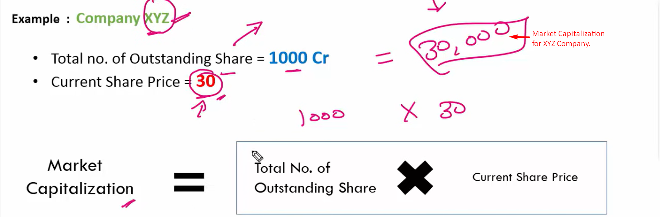  
        
      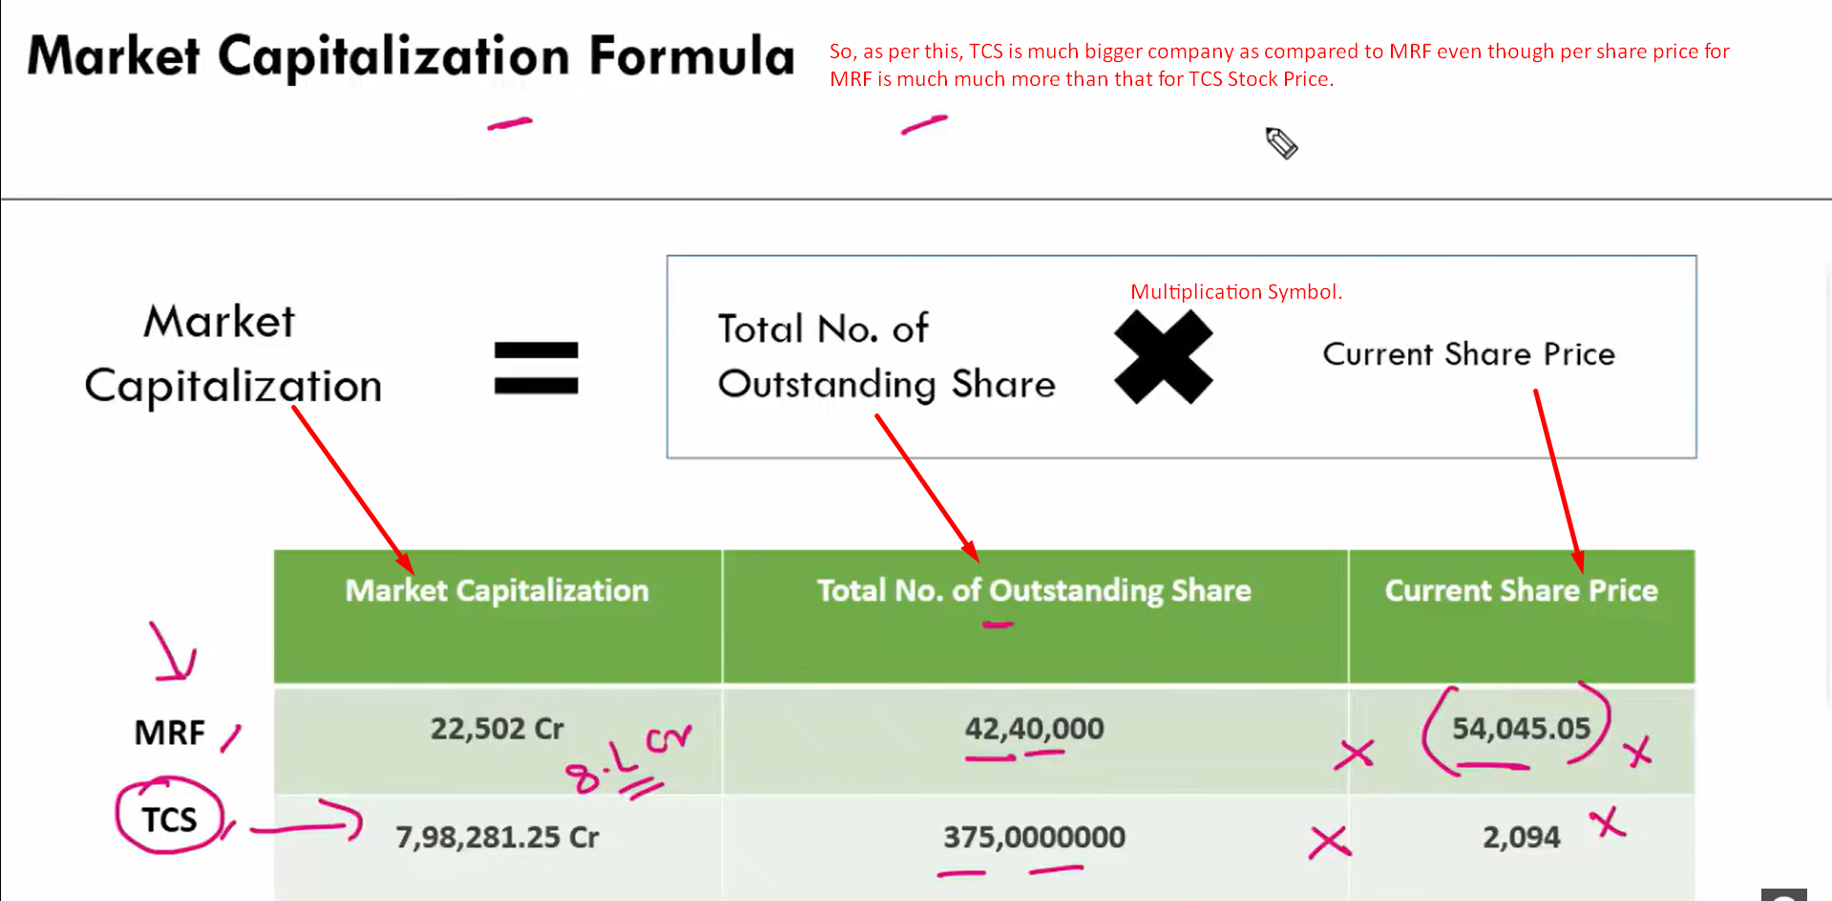
6. Graphical user interface, application, PowerPoint

   Description automatically generated